**Lend A Hand**

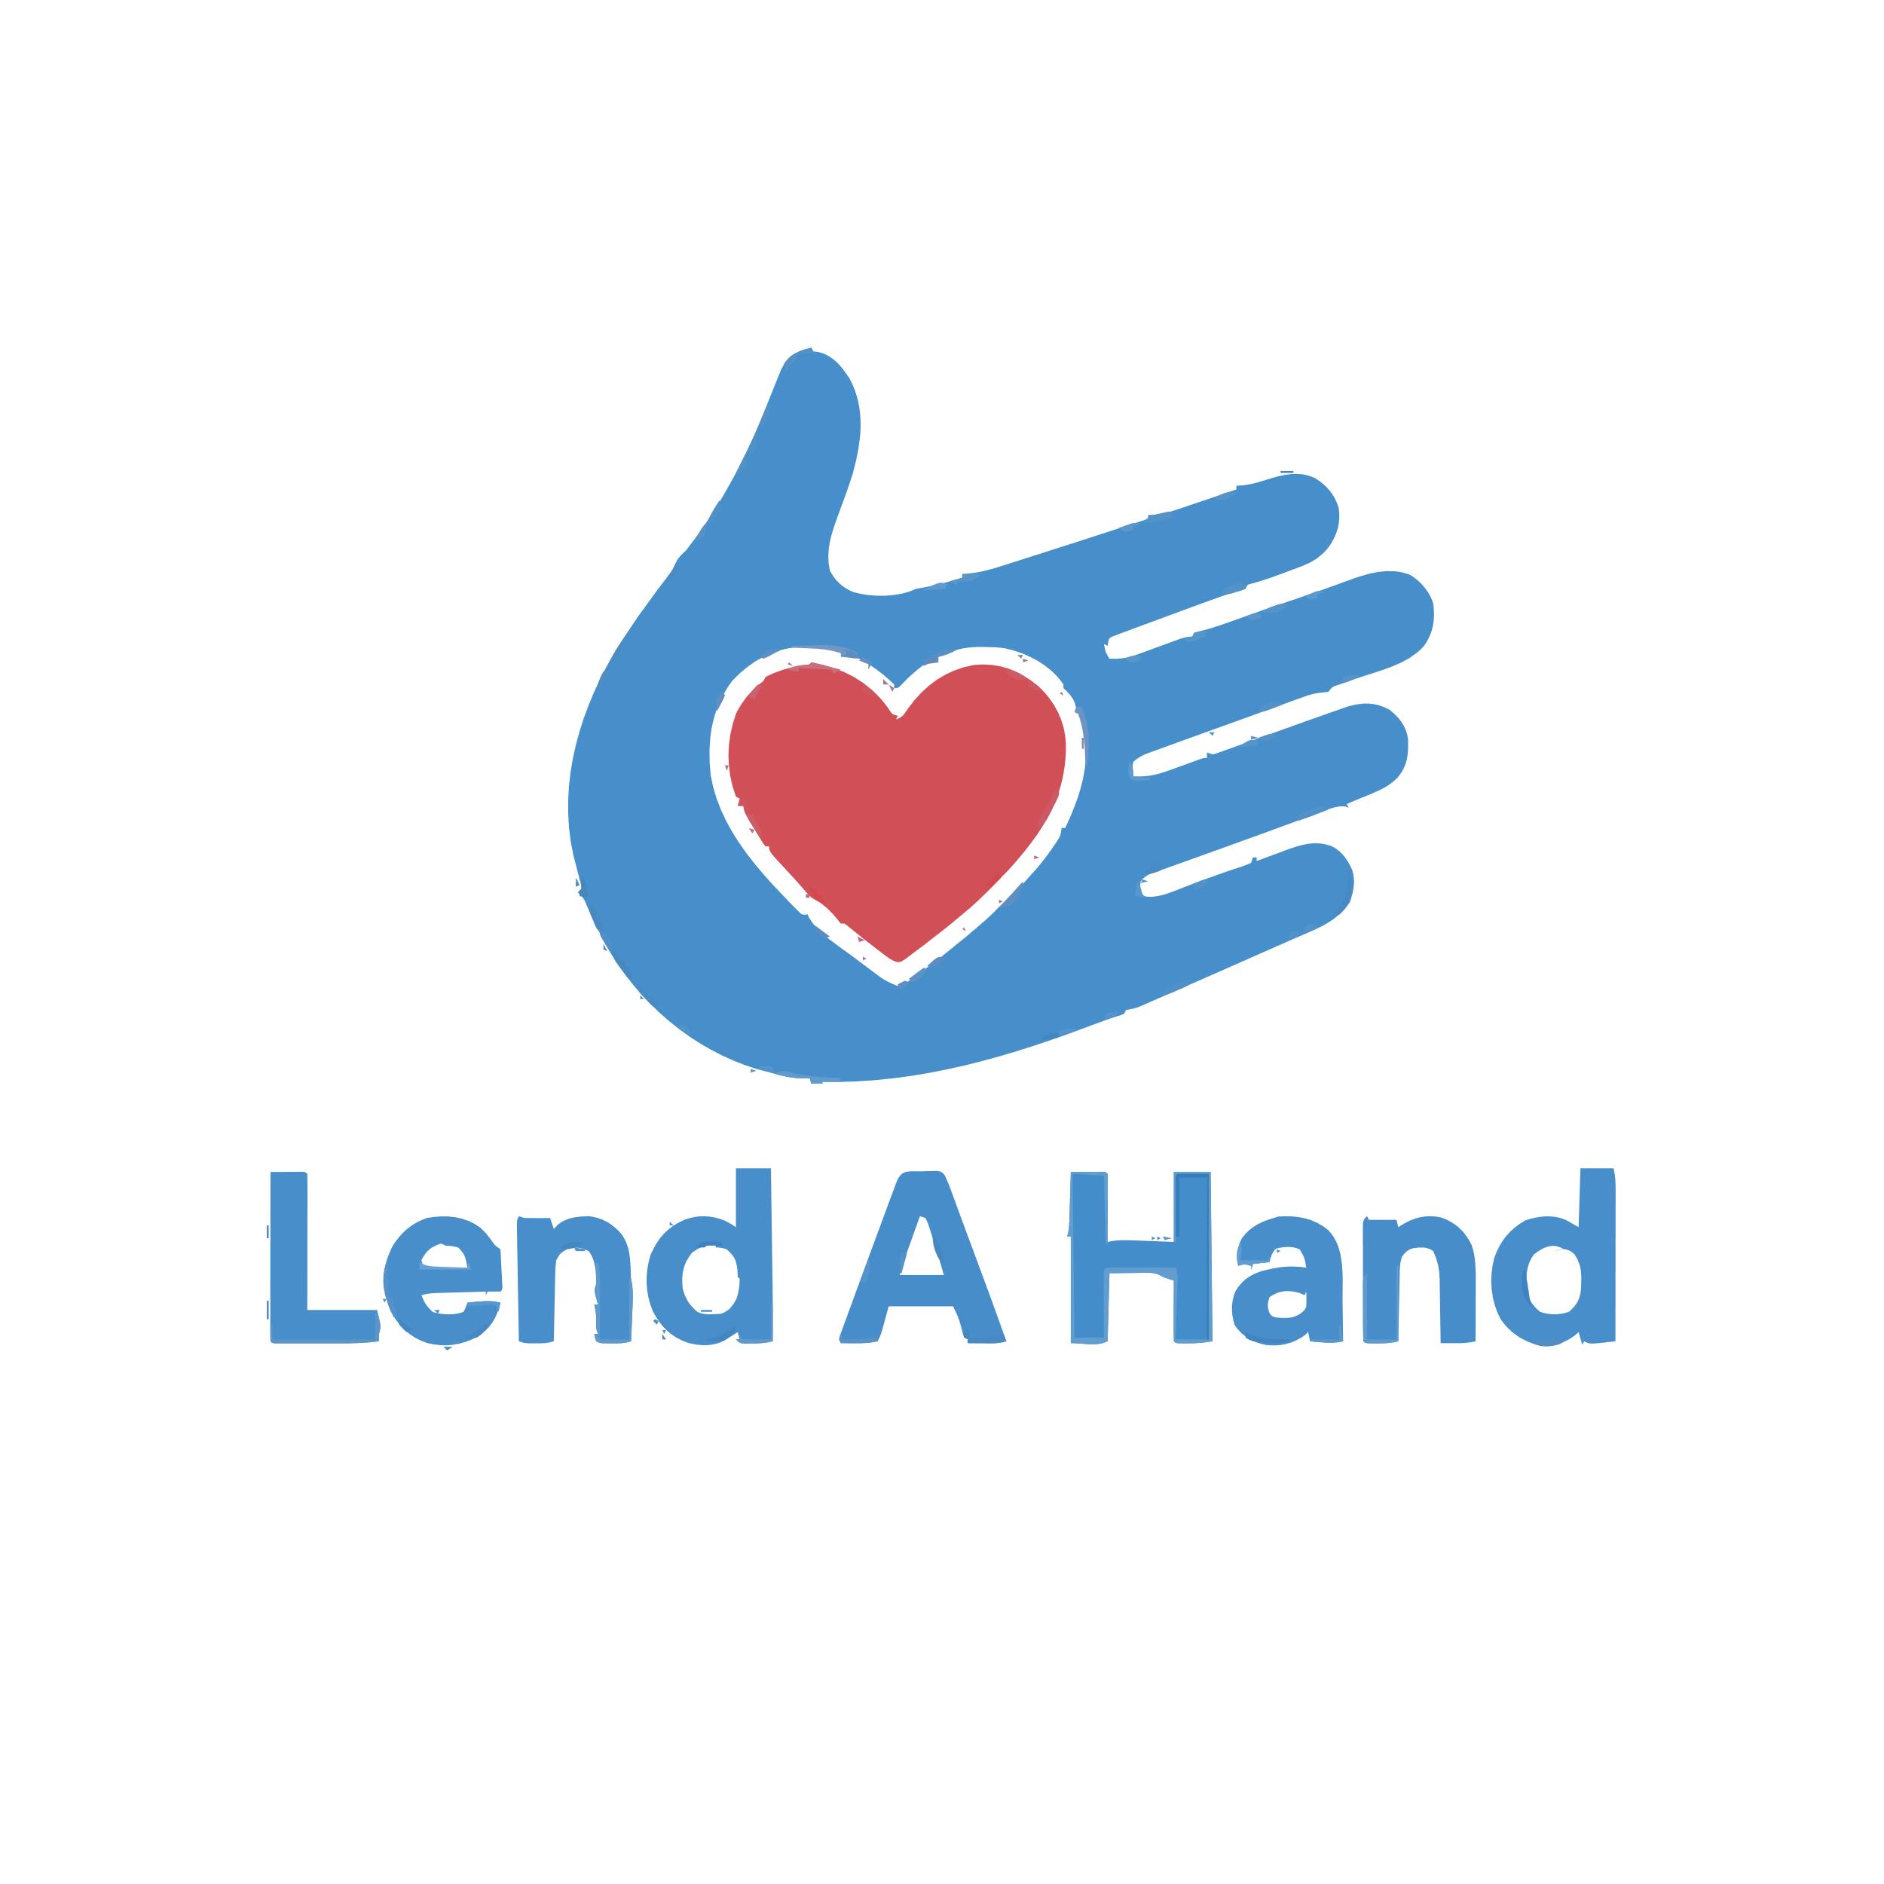

May 2025

COMS2002A

COMS2013A

|  |  |
| --- | --- |
| **Name** | **Student Number** |
| Dean Feldman | 2803899 |
| Liora Rosenberg | 2693084 |
| Nadav Sundy | 2698600 |
| Shayna Unterslak | 2799578 |

**Contents**

**Description of the procedures and processes involved in the Lend a Hand Project** 3

User Login in 3

User Sign up 3

Forgot Password 4

Donor Wall 4

Profile Page 5

Request Page 5

Donate Page 6

**Business Rules** 7

**Development of initial ERD** 8

**Recognition of issues in the initial ERD** 10

**Improved ERD** 10

**Implementation of Tables** 13

USERS Table 13

ITEM Table 13

REQUEST Table 13

DONATION Table 14

PASSWORD_RESETS Table 14

## **Description of the procedures and processes involved in the Lend a Hand Project**

### ***User Login in***

* The user will be asked to login
* The user will login by entering their email address and password using the “Login” Button
* The user input will be validated against the USERS table in the database
* If the input is valid, the user will be able to view the Donor Wall
* If the user forgot their password, there will be a “**Forgot password?**” option
* The user will be able to select a “**Sign up”** option if they do not have an account which will open a“**Sign up”** page

### 

***User Sign up***

* The user will enter their:
  + First name
  + Surname
  + Date of Birth (Using a date picker)
  + Email
  + Password
  + Confirm Password
* The input will be validated:
  + There is no existing account connected to the email address entered
    - If an account with this email already exists, “Email already registered” is displayed on a custom toast
    - The user will be able to return to the login screen
  + The email will be validated to ensure it has an @ symbol
  + The password must meet the following requirements:
    - At least 1 upper case letter
    - At least 1 lower case letter
    - At least 1 special character
    - At least 8 characters long
  + The user must be over 18
  + The date of birth selected is not in the future
  + The password and confirm password fields match
* Once the user has signed up successfully
  + They will receive a confirmation email
  + The login screen will open

### ***Forgot Password***

* The user will enter their email address
* The user will receive a One-Time-Pin via email to validate that they are the one changing their password that expired 15 minutes after it is sent
* The user enters the OTP
* The OTP is validated
* If the OTP is valid, the user will be able to change their password
* The user will need to enter their new password and re-enter to confirm it
* Once the password is changed, the user is returned to the login screen
* There is a “Back to Login” option

### ***Donor Wall***

* The user will be able to view all donors (first name, last name and amount donated) ordered by the number of items donated in a leaderboard form
* A user will be able to open the Profile Page by pressing on the Profile button at the bottom of the screen
* A user will be able to open the Donate Page by pressing on the Donate button at the bottom of the screen
* A user will be able to open the Request Page by pressing on the Request button at the bottom of the screen

***Profile Page***

* The user will view their:
  + Name
  + Email
  + Biography/Motivation
  + Your Activity:
    - You have donated
    - You have received
    - Your unfulfilled Requests
  + Donors who have helped you
* The user will be able to:
  + Add a short biography about themselves as a motivation for items they need (this is not required and can be left blank)
  + Edit their name
* The user will not be able to edit their email address
* A user will be able to return to the Donor Wall Page by pressing on the back arrow button at the top left of the screen
* The user will be able to log out using the button on the profile page

***Request Page***

* The users will select the item they need from a drop-down menu
* The user will select a quantity that they are looking for
* The user will click on the “Add Request” button
* These details will be added to the REQUEST table in the database
* The user will be able to select other items should they need them
* A user will be able to return to the Donor Wall Page by pressing on the back arrow button at the top left of the screen
* The user will get an email confirmation after making a request

***Donate Page***

* The users will select the item they want to donate from a drop-down menu
* The user will enter a quantity that they are willing to donate
* The user will then be shown a list of receivers (users that need this specific item) and the quantity they require
* The user will be able to view the receiver’s biography (if the receiver has one)
* The user will decide who they want to donate to and how much they are willing to donate
* Once the donor has selected who they donating to, both the donor and receiver will receive an email with the other person’s email address
* The quantity that the user can donate, will decrease
* The quantity that the receiver needs will decrease in the REQUEST table in the database
* If the receiver has received all the items they need, then the request is marked as fulfilled
* The user will be added to or updated in the donor wall
* The user will be able to select another item to donate
* A user will be able to return to the Donor Wall Page by pressing on the back arrow button at the top left of the screen
* Errors will be displayed if the user:
  + Tries to donate more items than the quantity they were willing to donate
  + Tries to donate more items than the receiver needs
* The “Donate to selected Receiver” button is only visible if the donation is valid
* Once the “Donate to selected Receiver” button is pressed:
  + A custom toast message confirms that the donation was successful
  + An animation of the “Lend a hand” logo is displayed on the screen
  + A dialog box appears, informing the user that a confirmation email has been sent to their address. It also displays the receiver’s email and confirms that they have been notified.

## **Business Rules**

* Each user must have a unique email address
* A user must be at least 18 years old to register
* A user’s date of birth must be in the past
* A user’s password must be at least 8 characters, with at least one uppercase letter, lowercase letter and one special character
* Passwords must be stored securely (hashed)
* A user that has donated an item will appear on the Donor Wall.
* The Donor Wall will appear in order of amount donated (from most to least)
* A donor must appear on the Donor Wall after their first donation.
* All users must be able to view the Donor Wall
* A user will be able to add a biography about themselves which the donor can view before deciding who to donate to.
* The user’s biography is not required.
* Users can only edit their own profile information
* The user cannot edit their email address.
* Users will only be able to receive or donate items from a predefined list.
* The predefined list of items is:

|  |  |  |  |
| --- | --- | --- | --- |
| Tinned Tuna | Rice | Maize Meal | Peanut butter |
| Bread | Eggs | Toilet Paper | Soap |
| Sanitary Pads | Baby Formula | Nappies | Blanket |
| Pens | Pencil | Eraser | Ruler |

* A user can request multiple items
* An item can be requested by multiple users
* A user can donate multiple items
* An item can be donated by multiple users
* A donation must reduce the donor’s available quantity and the receiver's needed quantity.
* A donation must link a donor user, a receiver user, and an item.
* Each donation contains 1 user (the donor) donating to 1 user (the receiver)
* If a donor donates the same item category to more than 1 person, it is considered more than 1 donation ( Ie, If User1 wants to donate 7 cans of tuna and they donate 5 to User2 and 2 to User3, it is considered 2 separate donations from User1 in the database)
* If the needed quantity reaches 0, the request is considered fulfilled and updated in the REQUEST table
* The user will be able to run the app in dark mode or light mode depending on your system settings
* A user will be able to update their password
* A user will only be able to update their password once they have validated their email address with an OTP
* Each OTP is only valid for 15 minutes
* The donor will be shown a Dialog box, as well as sent a confirmation email to confirm the donation
* The dialog box will have the receiver’s email address on it
* If a donation has been made to them, the receiver will be sent a notification email

## **Development of initial ERD**

The organisation depicted in the ERD has 5 entities

* USERS – information about each user
* ITEM- information about each item that can be donated
* REQUEST- information about the request for items a user makes
* DONATION- information about a donation that takes place
* PASSWORD_RESETS- used to store user_id and corresponding OTP details for resetting passwords

Each entity has the following:

Attributes:

* USERS
  + user_id (primary key)
  + user_fname
  + user_lname
  + user_dob
  + user_email (Unique)
  + user_password (hashed)
  + user_biography (nullable)
* ITEM
  + item_id (primary key)
  + item_name
* REQUEST
  + request_id (primary key)
  + user_id (foreign key to USERS)
  + item_id (foreign key to ITEM)
  + quantity_needed
  + fulfilled (Boolean)
* DONATION
  + donation_id (primary key)
  + donor_user_id (foreign key to USERS)
  + receiver_user_id (foreign key to USERS)
  + item_id (foreign key to ITEM)
  + quantity_donated
  + donation_date
* PASSWORD_RESETS
  + reset_id (primary key)
  + user_id (foreign key to USERS)
  + code
  + expires_at

Relationships:

* 1 user can make many requests
* A user does not have to make a request
* Each request can be made by 1 user
* Each request can be for a single item
* Each item can be requested many times
* An item does not have to be requested
* An item does not have to be donated
* Each item can be donated many times
* Each donation consists of a single item
* Each donation includes many users, one that donates and one that receives
* Each user can be involved in many donations
* Each user can reset their password many times
* A user does not have to reset their password
* Each reset password code can only be used once

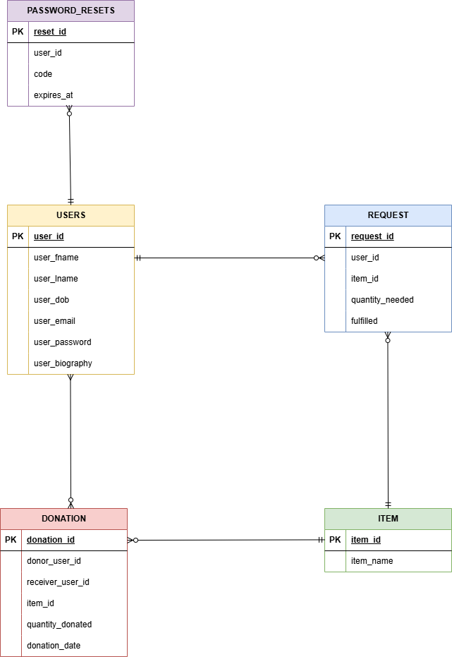

## **Recognition of issues in the initial ERD**

A Many-to-Many (M:N) Relationship exists between USERS and DONATION.

This is resolved by using the DONATION table as a bridge entity that links a donor user and a receiver user for each donation transaction.

Each donation also links to a specific ITEM, ensuring that the association between users and items remains normalized and structured.

The use of the DONATION table avoids any direct M:N relationship between users themselves and ensures that each donation event is properly recorded with details like quantity and date.

This ERD does not make use of any multivalued attributes.

Each request and donation is stored as a separate record, allowing users to request or donate multiple items without violating normalization principles.

In the USERS table, the user_biography field may have NULL entries as it is optional. Although NULL values are not ideal, this is necessary and unavoidable for this project to allow users flexibility in providing personal biographies for donors.

Additionally, foreign keys should be added to ensure that the ERD is a complete representation of the database.

## **Improved ERD**

The organisation depicted in the improved ERD has 5 entities

* USERS – information about each user
* ITEM- information about each item that can be donated
* REQUEST- information about the request for items a user makes
* DONATION- information about a donation that takes place
* PASSWORD_RESETS- used to store user_id and corresponding OTP details for resetting passwords

Each entity has the following:

Attributes:

* + USERS
    - user_id (primary key)
    - user_fname
    - user_lname
    - user_dob
    - user_email (Unique)
    - user_password (hashed)
    - user_biography (nullable)
  + ITEM
    - item_id (primary key)
    - item_name
  + REQUEST
    - request_id (primary key)
    - user_id (foreign key to USERS)
    - item_id (foreign key to ITEM)
    - quantity_needed
    - fulfilled (Boolean)
  + DONATION
    - donation_id (primary key)
    - donor_user_id (foreign key to USERS)
    - request_id (foreign key to REQUEST)
    - quantity_donated
    - donation_date
  + PASSWORD_RESETS
    - reset_id (primary key)
    - user_id (foreign key to USERS)
    - code
    - expires_at

Relationships:

* 1 user can make many requests
* Each request can be made by 1 user
* A user does not have to make a request
* Each request can be for a single item
* Each item can be requested many times
* An item does not have to be requested
* An item does not have to be donated
* Each item can be donated many times
* Each donation consists of a single item
* Each donation is directed at one request
* Each request is fulfilled by one or many donations
* Each user can reset their password many times
* A user does not have to reset their password
* Each reset password code can be used once

Following the development of the updated ERD, the database will be implemented using a relational database management system (RDBMS) using MySQL. Tables for USERS, ITEM, REQUEST, DONATION and PASSWORD_RESETS will be created according to the improved design, with appropriate primary keys, foreign keys, and constraints to enforce referential integrity.

Passwords will be securely stored using hashing techniques to ensure user security.

The user_biography field will be set as nullable to allow flexibility during user profile creation.

Overall, the database implementation will closely follow the final ERD to ensure a normalized, efficient, and secure system ready to support the Lend a Hand mobile application.

## **Implementation of Tables**

### USERS Table

CREATE TABLE USERS (

user_id INT PRIMARY KEY AUTO_INCREMENT,

user_fname VARCHAR(50) NOT NULL,

user_lname VARCHAR(50) NOT NULL,

user_dob DATE NOT NULL,

user_email VARCHAR(100) NOT NULL UNIQUE,

user_password VARCHAR(255) NOT NULL,

user_biography TEXT);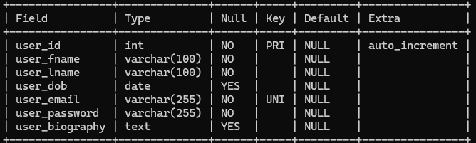

### ITEM Table

CREATE TABLE ITEM (

item_id INT PRIMARY KEY AUTO_INCREMENT,

item_name VARCHAR(100) NOT NULL

### REQUEST Table

CREATE TABLE REQUEST (

request_id INT PRIMARY KEY AUTO_INCREMENT,

user_id INT NOT NULL,

item_id INT NOT NULL,

quantity_needed INT NOT NULL,

fulfilled BOOLEAN DEFAULT FALSE,

FOREIGN KEY (user_id) REFERENCES USERS(user_id),

FOREIGN KEY (item_id) REFERENCES ITEM(item_id)

);

*Note that MYSQL converts BOOLEAN to tinyint(1)

### ***DONATION Table***

CREATE TABLE DONATION (

donation_id INT PRIMARY KEY AUTO_INCREMENT,

donor_user_id INT NOT NULL,

request_id INT NOT NULL,

quantity_donated INT NOT NULL,

donation_date DATE NOT NULL,

FOREIGN KEY (donor_user_id) REFERENCES USERS(user_id),

FOREIGN KEY (request_id) REFERENCES REQUEST(request_id)

);

### ***PASSWORD_RESETS Table***

CREATE TABLE PASSWORD_RESETS (

reset_id INT PRIMARY KEY AUTO_INCREMENT,

user_id INT,

code VARCHAR(10) NOT NULL,

expires_at DATETIME NOT NULL,

FOREIGN KEY (user_id) REFERENCES USERS(user_id) ON DELETE CASCADE

);

